Please Check:

Graduate Midwife Registered Nurse

Name of Applicant: ________________________________________ School: __________________________________________

Name and Address of Patient | Case No. | Complete Diagnosis | Date & Time Performed | Full Name, Address of Facility & Contact Number | Supervised by:
 |  |  |  |  | Printed Name & Contact No. | Position/ Designation | Signature | License No./ Expiration Date
1.
2.
3.
4.
5.
Note: 1) Registered Midwives/Clinical Instructors who supervise Students/Graduate Midwives/Registered Nurses and affix their signature in this Form must present
Certificate of Training on Expanded Functions of Midwife (R.A. 7392) pursuant to Board Resolution No. 07, Series of 2017, dated September 8, 2017.

(See back page)

Name of Applicant: _____________________________________ School: ____________________________________________

Name and Address of Patient | Case No. | Complete Diagnosis | Date & Time Performed | Full Name, Address of Facility & Contact Number | Supervised by:
 |  |  |  |  | Printed Name & Contact No. | Position/ Designation | Signature | License No./ Expiration Date
1.
2.
3.
4.
5.
Note: 1) Registered Midwives/Clinical Instructors who supervise Students/Graduate Midwives/Registered Nurses and affix their signature in this Form must present a
Certificate of Training on Expanded Functions of Midwife (R.A. 7392) pursuant to Board Resolution No. 07, Series of 2017, dated September 8, 2017.

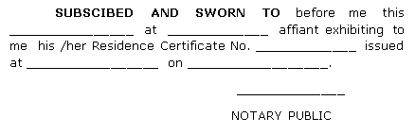
Affix
Documentary Stamp
(to be posted on the last page)
CERTIFIED CORRECT:

Signature: Date: Printed Name: Designation: ____________________________ Number: Expiry Date:

